Udacity CarND Term 2 Project 5 Model Predictive Control

Brian Meier
8/29/17
Table of Contents
Abstract 3
Algorithm Description 3
Obtain Waypoints and Car State 3
Transform Waypoints and Car State 4
Fit Third-Order Polynomial 4
Minimize Cost Function 7
Motion Model 7

Abstract
Model predictive control, MPC, uses optimization methods to predict the trajectory of a car. Inputs are a set of waypoints, car state position, bearing and velocity values. Outputs are the steering and throttle control values. This report describes an MPC algorithm devised, and implemented to control a car run on the Udacity self_driving_car_nanodegree_program MPC simulator.

Algorithm Description
- Obtain waypoints and car state.
- Transform waypoints and car state from map to car coordinates.
- Fit a third-order polynomial to the waypoints.
- Minimize a cost function to determine the optimal actuator values at future time steps. The current step is step 0. Future actuator values are given in time steps 1, 2, .. N. The time between each step is equal to the latency time between a signal being sent the actuation occurring.
- At the next step, the actuator values are set that given by to that given that given by time step 1.
- Repeat steps one through five.

Obtain Waypoints and Car State
Waypoints consist of the next six positions. These are given in the map coordinate system and the unit of measure is meters.
The car state consists of the car x and y coordinates, bearing, speed, and measured steering position and throttle position. Coordinates are in the map reference frame and the unit of measure is meters. The bearing is the direction the car is heading and is measured relative to the map x-axis in radians. The car speed is measured in miles per hour.
Term | Term | UOM | Limits | Ref. Frame
x_{waypoint1, 2, .. 6} | Waypoint x-coordinates. | meter |  | Map
y_{waypoint1, 2, .. 6} | Waypoint y-coordinates. | meter |  | Map
x_{car map} | Car x-coordinate. | meter |  | Map
y_{car map} | Car y-coordinate. | meter |  | Map
ψ_{car map} | Car bearing. Counter clockwise from the x-axis. | radians |  | Map
v_{car} | Car speed. | miles/ hour |  | N/ A
δ_{meas} | Steering angle in the clockwise direction. | radians | ± 25° | Car
a_{meas} | Throttle position. | # | ± 1 | N/ A

Transform Waypoints and Car State
The car x, y and ψ values are each transformed to 0. Each waypoint is transformed by the below equation.

This ensures that the y(x) is single valued and allows for y – y_{fit} be a good estimate for a cross track error.

Fit Third-Order Polynomial
Polynomial fits allow for efficient calculation of values and their derivatives. However, if the fit is poor, or multi-valued, problems exist. For this project a third-order polynomial was used. The fit accommodates changes in curvature and can model S-turns. However, if the data is not transformed, obtaining a function in the below form can lead to poor results.

For the below plots, a circle was rotated and fit. For this example, the car bearing is parallel with the circle at its start point.

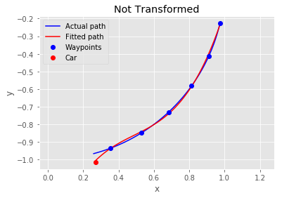
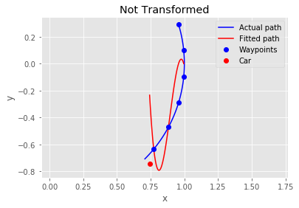
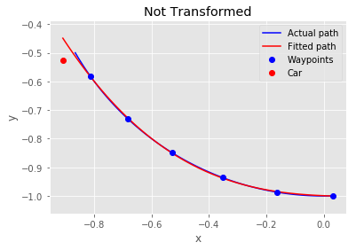

Alternatively, transforming the waypoints from map to car coordinates prior to fitting, leads to a good approximation.

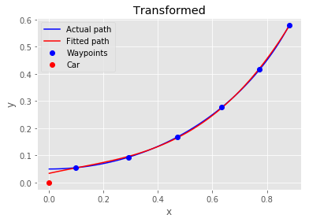
An added benefit of performing the translation and rotation transformations is it allows for an efficient estimate of the cross-track error, CTE, and the bearing error, ψ_{e}. The cross-track error and bearing errors are given bye the below equations.

Given transformed waypoints, y_{wt[i]} and x_{wt[i]}, the below cost function J_{fit}, is minimized to yields the coefficients, c₃, c₂, c₁, and c₀.

Minimize Cost Function
Three steps are required to determine the cost function.
- Determine motion model
- Define penalty terms
- Scale and sum penalties

Motion Model

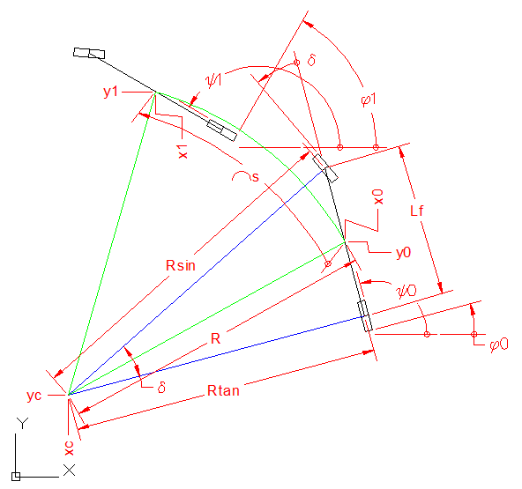

The motion model used is a constant turning radius, constant acceleration, model. Governing equations are given below.

If δ is zero then the below equations hold.

If If δ is not zero, then the below equations hold. It is noted that the turning radius, R, is an estimate. The bounds given below show that this estimate is reasonable.

Definition of Penalty Terms
Errors used in the optimization algorithm are the following:
CT_{e} Cross-track error, meters
ψ_{e} Bearing error, radians
Δδ Change in steering angle in one time step, radians
ΔCT_{e} Change in cross-track error in one time step, meters
la_{e} Lateral acceleration deviation from set point, meters per second squared
For relevant a time steps, i, errors are given by the equations listed below.

Scaling and Summation of Penalty Terms
The implementation takes as a given the state (x, y, ψ, v) and the actuations (δ, a). After a latency of 100 ms, the next actuation values are implemented. The solution consists of N points, including the initial state at time t = 0. Actuations are given at times Δt, 2Δt, 2Δt, … (N-2)Δt. Therefore, states are affected at times 2Δt, 3Δt, 4Δt, … (N-1)Δt. The length of each time step, Δt, is set to 100 ms to match the latency. The cost function, J, to be minimized is given below.

Selection of Parameter Values

